EXPT NO:1 | Implementation of data charts
Roll No: 23BAD079 | Implementation of data charts
DATE: 06.01.2026 | Implementation of data charts

PRE-LAB QUESTIONS (PROVIDE BRIEF ANSWERS TO THE FOLLOWING QUESTIONS)

- How can visualization help an academic institution improve student outcomes?
- Which chart types are suitable for comparing subject-wise performance?
- What type of data scale is used for student marks?
- Why should raw academic data be cleaned before visualization?
- How does visualization support evidence-based decision making?

Answers:

- Visualization helps institutions easily identify patterns, trends, and problem areas in student performance. By viewing data such as grades, attendance, and pass/fail rates graphically, institutions can spot weak subjects, struggling students, and performance gaps early, allowing timely interventions like remedial classes or mentoring.

- • Bar charts – best for comparing average marks across different subjects
• Column charts – like bar charts, useful for subject-wise comparison
• Box plots – helpful to compare score distribution and variability across subjects

- Student marks use an interval scale of measurement because:
- The difference between values is meaningful (e.g., difference between 60 and 70)
- There is no true zero that represents the absence of performance.

- Raw data may contain missing values, duplicate entries, or errors. Cleaning ensures:
- Accurate and reliable visualizations
- Avoidance of misleading conclusions
- Better clarity and consistency in charts

- Visualization converts complex data into clear and understandable insights, enabling administrators and educators to:
- Make decisions based on actual performance trends
- Justify policies using data evidence
- Monitor the impact of academic interventions effectively

IN-LAB EXERCISE:
OBJECTIVE:
To design appropriate data charts to analyze and compare academic performance indicators.
SCENARIO:
An autonomous engineering college wants to analyze internal assessment performance of first-year students across five subjects to identify difficult courses and improve teaching strategies.
IN-LAB TASKS (Using R Language)
- Load required R libraries (ggplot2, dplyr)
- Import dataset using read.csv()
- Perform basic data preprocessing
- Create bar chart for subject-wise average marks
- Generate line chart for performance trend across tests
- Plot pie chart for grade distribution

(CODE: CONATAINS STUDENT ROLL NOS
SCREENSHOT OF CODE
SCREENSHOT OF OUTPUT)

Code:
getwd()
install.packages("ggplot2")
install.packages("dplyr")
library(ggplot2)
library(dplyr)
data <- read.csv("1.student_performance.csv")
head(data)
sum(is.na(data))
data <- data %>%
mutate(Internal_Avg = (Internal_Test1 + Internal_Test2 + Assignment_Marks) / 3)

subject_avg <- data %>%
group_by(Subject) %>%
summarise(Average_Marks = mean(Internal_Avg))

ggplot(subject_avg, aes(x = Subject, y = Average_Marks, fill = Subject)) +
geom_bar(stat = "identity") +
labs(title = "Subject-wise Average Internal Marks",
x = "Subject",
y = "Average Marks") +
theme_minimal()

test_trend <- data %>%
summarise(
Test1 = mean(Internal_Test1),
Test2 = mean(Internal_Test2),
Assignment = mean(Assignment_Marks)
)

trend_data <- data.frame(
Assessment = c("Internal Test 1", "Internal Test 2", "Assignment"),
Average = as.numeric(test_trend)
)

ggplot(trend_data, aes(x = Assessment, y = Average, group = 1)) +
geom_line() +
geom_point() +
labs(title = "Performance Trend Across Assessments",
x = "Assessment",
y = "Average Marks") +
theme_minimal()

grade_dist <- data %>%
count(Final_Grade)

ggplot(grade_dist, aes(x = "", y = n, fill = Final_Grade)) +
geom_bar(stat = "identity", width = 1) +
coord_polar("y") +
labs(title = "Final Grade Distribution") +
theme_void()

OUTPUT:

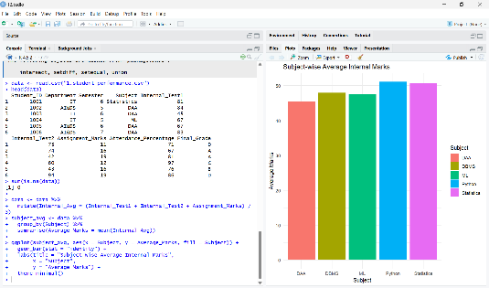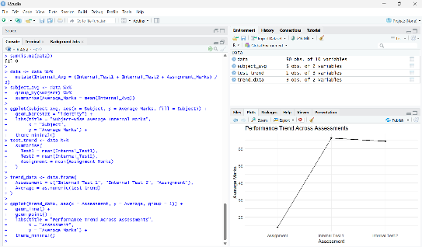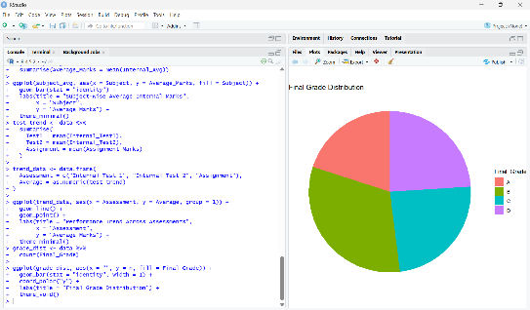

POST-LAB QUESTIONS (PROVIDE BRIEF ANSWERS TO THE FOLLOWING QUESTIONS)
- Which subject shows consistently low performance and why?
- Why is a line chart suitable for trend analysis?
- What limitations does a pie chart have in analytics?
- How can this analysis help curriculum planning?
- How can such visualizations be integrated into AI-driven academic analytics

ANSWERS:

- From the subject-wise average internal marks bar chart, DAA (Design and Analysis of Algorithms) shows consistently low performance. This may be due to its high conceptual difficulty, problem-solving nature, and students’ limited exposure to algorithmic thinking in the first year.

- A line chart is suitable for trend analysis because it clearly represents changes across sequential assessments. It helps in identifying whether student performance is improving, declining, or remaining stable over time, which is difficult to observe using other chart types.

- Pie charts have the following limitations:
- Difficult to compare small differences between categories
- Not suitable for large or complex datasets
- Cannot show trends or relationships
- This analysis helps curriculum planners to:
- Identify difficult subjects like DAA
- Introduce additional tutorials, labs, or remedial sessions
- Revise assessment strategies
- Improve teaching methods and resource allocation
- These visualizations can be integrated with AI systems to:
- Predict student performance and risk of failure
- Enable early-warning systems
- Support personalized learning recommendations
- Provide real-time academic dashboards for administrators
ASSESSMENT
Description | Max Marks | Marks Awarded
Pre Lab Exercise | 5
In Lab Exercise | 10
Post Lab Exercise | 5
Viva | 10
Total | 30
Faculty Signature

